

崇新学堂

2025－2026学年第一学期

实 验 报 告

课程名称： 电子信息工程导论
实验名称： For Your Eyes Only

专 业 班 级 崇新学堂
学 生 姓 名 高子轩，钱竹玉，吕思洁，徐亚骐
实 验 时 间 2025年11月5日

CMax to the Rescue
Step 2: After CMax was run, we checked the version by pressing ctrl+a. A window popped up, showing its CMax version 1.5.2.

Figure 1 The plot for CMax version 1.5.2.
Step 4：A schematic diagram for the circuit shown in the CMax window.
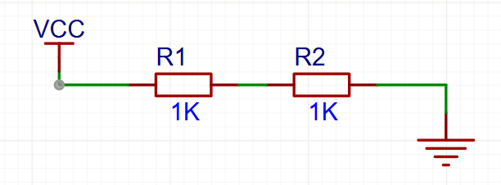
Figure 2 The schematic circuit diagram for mystery.cmax
Step 5: The predicted calculation result
$$V_{o}=\frac{R_{2}}{R_{1}+R_{2}}V_{i}$$
Therefore $V_{o}$ should be 5.0V.
Step 6: Simulation for mystery.cmax
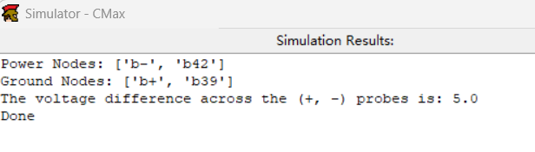
Figure 3 Simulation for mystery.cmax
$V_{o}$ in simulation is also 5.0V, so the calculations match the simulation.
Voltage Dividers
Step7：Lay out this circuit using CMax.
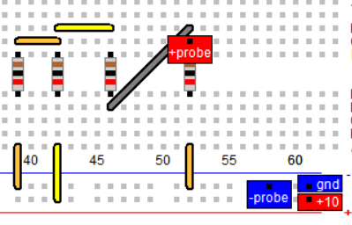
Figure 4 The CMax layout for the voltage divider
Check Yourself 1. What is the simulated value of $V_{o}$?
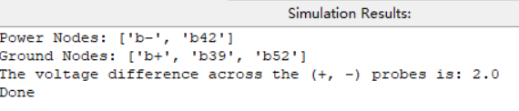
Figure 5 Simulation for voltage divider
The answer：the simulated value of $V_{o}$ is 2.0V
Check Yourself 2. Calculate $V_{o}$ using circuit theory.
We equate the parallel resistors to a single resistor $R_{eq}$
$$R_{eq}=\frac{2R×R}{2R+R}$$
We further perform voltage division calculation and calculate $V_{o}$
$$V_{o}=\frac{R_{eq}}{R_{eq}+R}×\frac{R}{R+R}V_{i}=\frac{1}{5}V_{i}=2.0V$$
Checkoff 1. Explain why $V_{o}$ is not a quarter of $V_{i}$
When the two voltage dividers are directly connected, the input terminal of the second voltage divider (i.e., between the two resistors) will be connected to the output terminal of the first voltage divider, so that the voltage distributed by the second voltage divider is less than a quarter of the total voltage.
Potentiometer
Step 9：What are the min and max voltages at the middle terminal of the potentiometer?
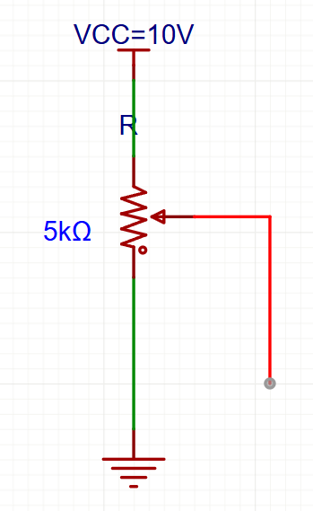
Figure 6 The schematic circuit diagram for potentiometer
The answer: Minimum value:0V Maximum value:10V
Step 10: To what value of $α$ does this correspond?
The simulated result
Since the actual device is unavailable, we used Multisim simulation to calculate.
Here is the circuit we simulated
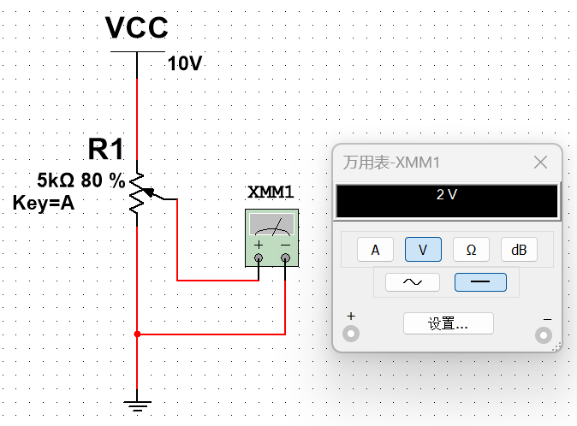
Figure 7 The Multisim simulation plot
The theory result
Using the voltage division theorem, we can determine $V_{o}$.
$$V_{o}=V_{i}×\frac{R_{bottom}}{R_{total}}$$
Substitute the value related to $α$
$$V_{o}=V_{i}×\frac{αR}{R}=0.2$$
We solve that
$$α=0.2$$
The answer: $α=0.2$
Step 11. Measure the voltage $V_{o}$ at the middle terminal.
Here is the circuit we simulated
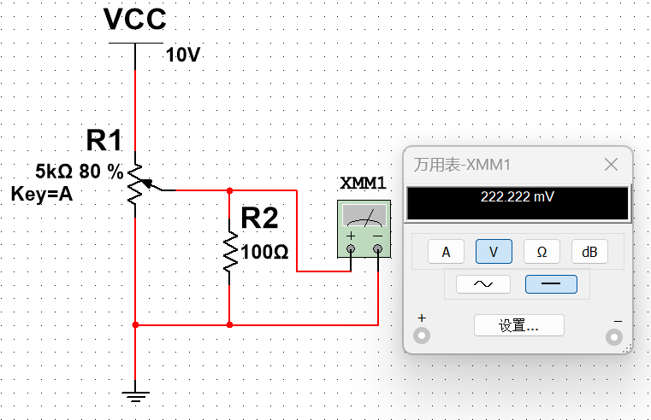
Figure 8 The Multisim simulation plot
After measurement, $V_{o}=0.222222V$
Step 12. Use circuit theory to compute the ideal value of $V_{o}$ in this circuit.
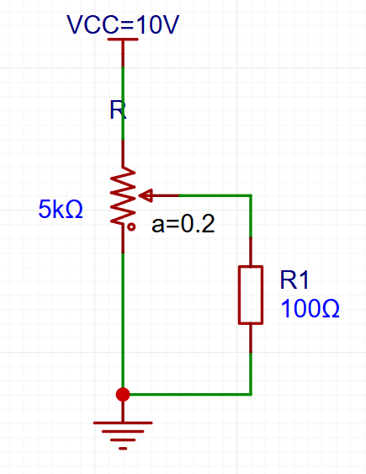
Figure 9 The schematic circuit diagram
We calculate the parallel resistance $R_{eq}$ first
$$R_{eq} = R_{1}//R_{bottom}$$
Using the voltage divider theorem to calculate $V_{o}$
$$V_{o}=\frac{R_{eq}}{R_{eq}+R_{top}}×10=0.22V$$
Step 13. What is the voltage $V_{o}$ at the middle terminal?
We used Multisim simulation instead of actual measurements, with the results as follows:
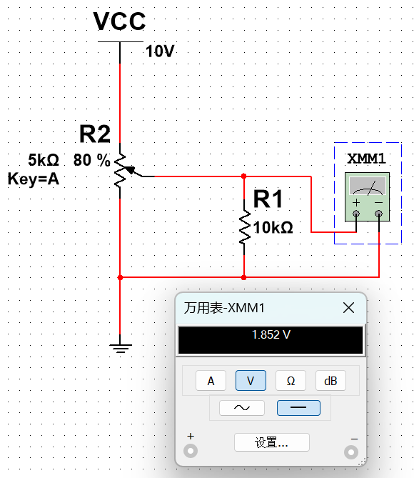
Figure 10 The Multisim simulation plot
Here is the CMax’s simulation result
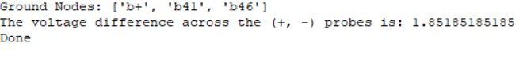
Figure 11 Simulation for Potentiometer
After measurement, $V_{o}=1.852V$
Step 14. Use circuit theory to compute the ideal value of $V_{o}$ in this circuit.
We calculate the parallel resistance $R_{eq}$below first
$$R_{eq}=R_{1}//R_{bottom}$$
Using the voltage division theorem to calculate $V_{o}$
$$V_{o}=\frac{R_{eq}}{R_{eq}+R_{top}}×V_{i}≈1.85V$$
Step 15. Measure resistance at different light intensities
Due to the damage of the photoresistor, all our numerical solutions were derived from the measurements of the senior.
Here is our answer:
 | Left ($Ω$) | Right ($Ω$)
Ambient light | $$4k$$ | $$5k$$
one foot in front of lamp | $$1k$$ | $$1.5k$$
three feet in front of lamp | $$2k$$ | $$2.5k$$

Step 16. Sketch your circuit below.
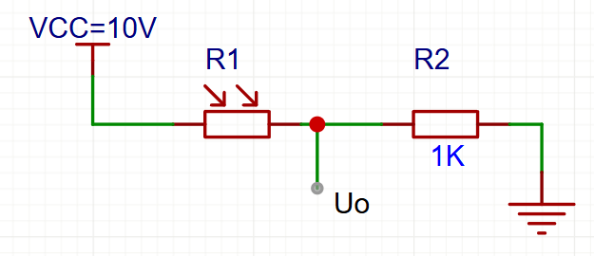
Figure 12 The schematic circuit diagram
We choose the $R_{2}=1kΩ$ and use the voltage divider theorem to calculate the output voltage $V_{o}$
When the light is on
$$V_{bright}=V_{cc}×\frac{R_{2}}{R_{left}+R_{2}}=5.0V$$
When the light is off
$$V_{dark}=V_{cc}×\frac{R_{2}}{R_{left}+R_{2}}=2.0V$$
We meet the requirement of a voltage difference greater than 3V
$$ΔV=V_{bright }-V_{dark}=3V$$

 | Left ($V$) | Right ($V$)
Ambient light | $$2V$$ | $$1.66V$$
one foot in front of lamp | $$5V$$ | $$4V$$
three feet in front of lamp | $$3.33V$$ | $$2.86V$$
Check Yourself 4. Explain how your circuit generates a low voltage under ambient conditions and a higher voltage under bright conditions.
In the circuit, the photoresistor is connected in series with a $1kΩ$ resistor.
When the ambient light becomes brighter, the resistance value of the photoresistor decreases, the voltage division reduces, and the voltage division of the fixed resistor increases, that is, the output voltage increases.
When the ambient light dims, the resistance value of the photoresistor increases, the voltage division increases, and the voltage division of the fixed resistor decreases, that is, the output voltage becomes smaller.

Here is the schematic for two photoresistor circuits
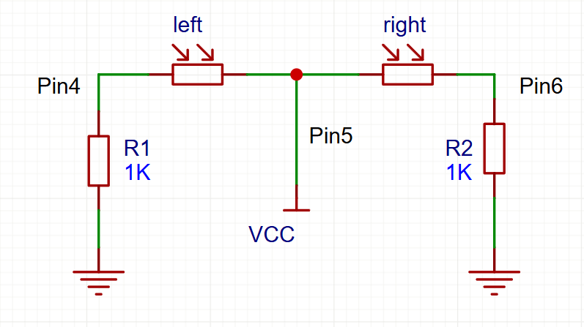
Figure 13 The schematic diagram for the “head”
Step 17. Use CMax to simulate the two photoresistor circuits
As we know, Robot Connector's Pin2 serves as the power supply and Pin4 as the ground, so we implemented this configuration in CMax.
As shown in the schematic, Pins 4 and 6 of the Head Connector connect to the left and right photoresistors respectively. We connect two resistors to these pins and ground them, while Pin5 is used for power supply.
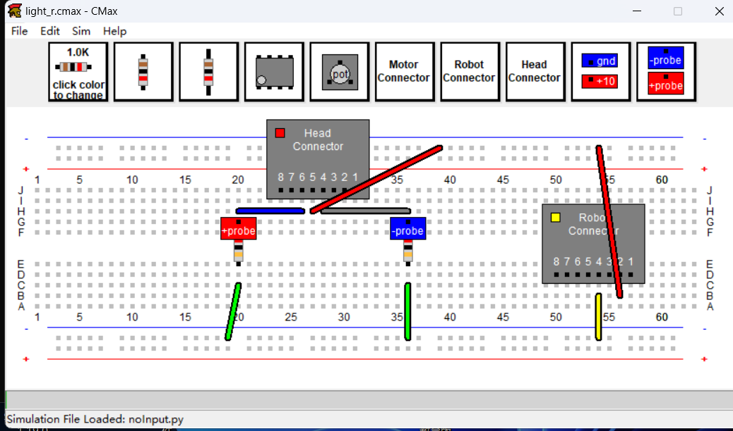
Figure 14 The CMax layout for the “head”
Check Yourself 5. Explain our CMax simulation chart and the measured voltage’s change when light moves from left to right. 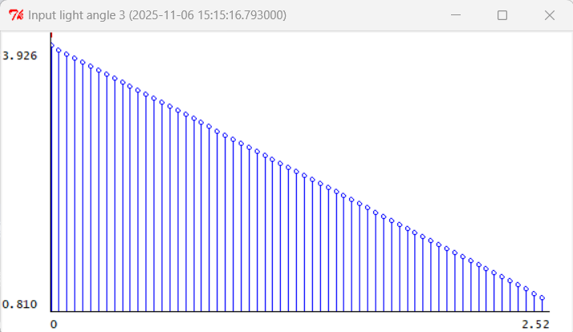
Figure 15 The light condition
$V_{L}$：When the light source moves from the left to the right, as shown in the simulation, $V_{L}$ changes in a trend approximately quadratic (first increasing and then decreasing).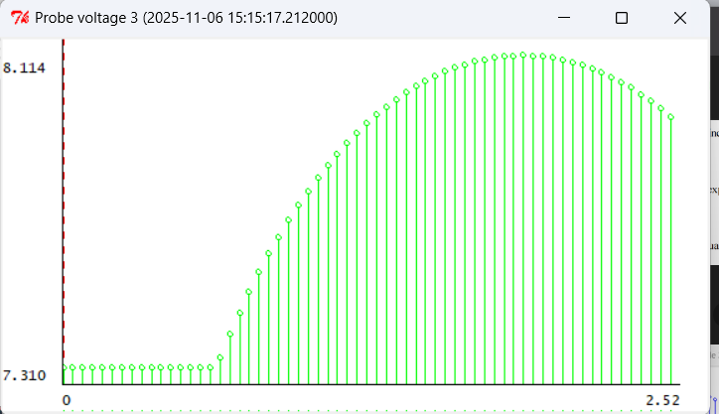
Figure 16 The trend chart of $V_{L}$
$V_{R}$：When the light source moves from the right to the left, as shown in the simulation, $V_{L}$ changes in a trend approximately quadratic (first increasing and then decreasing), Finally, it approaches zero.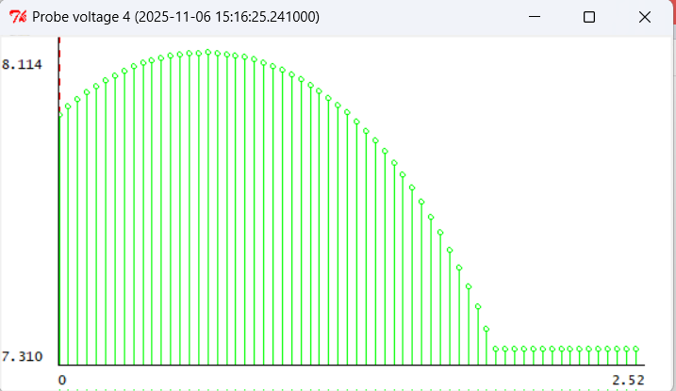
Figure 17 The trend chart of $V_{R}$
$V_{L}$-$V_{R}$： When the light source moves from left to right, as shown in the simulation, $V_{L}$ is initially negative and its absolute value first increases and then decreases. Then it gradually changes from negative to positive and maintains the trend of first increasing and then decreasing again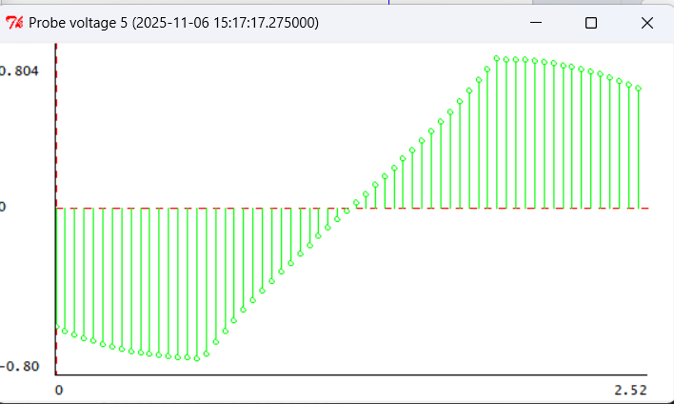
Figure 18 The trend chart of $V_{L}$-$V_{R}$
Checkoff2 Explain how we orient ourselves toward the light source
• If the voltage on the left is significantly greater than that on the right, it indicates that the light source is on the left. Then, control the car to turn left by a large margin.
• If the voltage on the left is slightly greater than that on the right, it indicates that the light source is on the left. Then, control the car to turn left by a small margin.
• If the voltage on the left is almost equal to that on the right, it indicates that the light source is in front. Then, control the car to continue going straight.
• If the voltage on the right is slightly higher than that on the left, it indicates that the light source is on the left, and then control the car to turn to the right with a small amplitude.
• If the voltage on the right is significantly higher than that on the left, it indicates that the light source is on the left, and then control the car to turn to the right with a large amplitude.
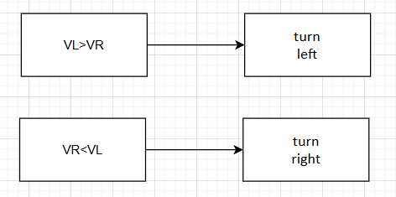
Figure 19 Our specific building logic
Appendix1: Multisim Simulation Explanation
As noted earlier, we employed Multisim to substitute for actual measurements due to equipment failure.
Appendix2: The Description of AI Usage in the Report
We utilized AI to better understand the characteristics of photoresistors. In the inspection of some circuit designs, we employed AI tools. In the translation of certain contents, to ensure accuracy, we used a small amount of AI for polishing

